**Carrying out data wrangling and analysis in SQL to uncover insights in underutilized data.**

**Introduction**

For this task, we performed data wrangling and analysis in SQL using the [Telco Customer Churn dataset](https://www.kaggle.com/datasets/blastchar/telco-customer-churn) obtained from Kaggle. The objective was to explore and uncover business insights from potentially underutilized customer data, focusing on patterns that may influence churn. The entire process was executed using MySQL Workbench as the database interface.

**Step 1: Data Import and Preparation**

We began by creating a new database called telco2_db and defined a table customer_churn using SQL DDL (Data Definition Language). We then imported the CSV file into this table using MySQL Workbench’s Table Data Import Wizard.

**Step 2: Data Wrangling and Analysis**

To gain insights from the data, we wrote several SQL queries involving grouping, aggregation, ordering, and filtering. Below are key findings.

1. **Churn Count Summary**

To show split between churned and retained customers, the study used the SQL command highlighted in the figure below.

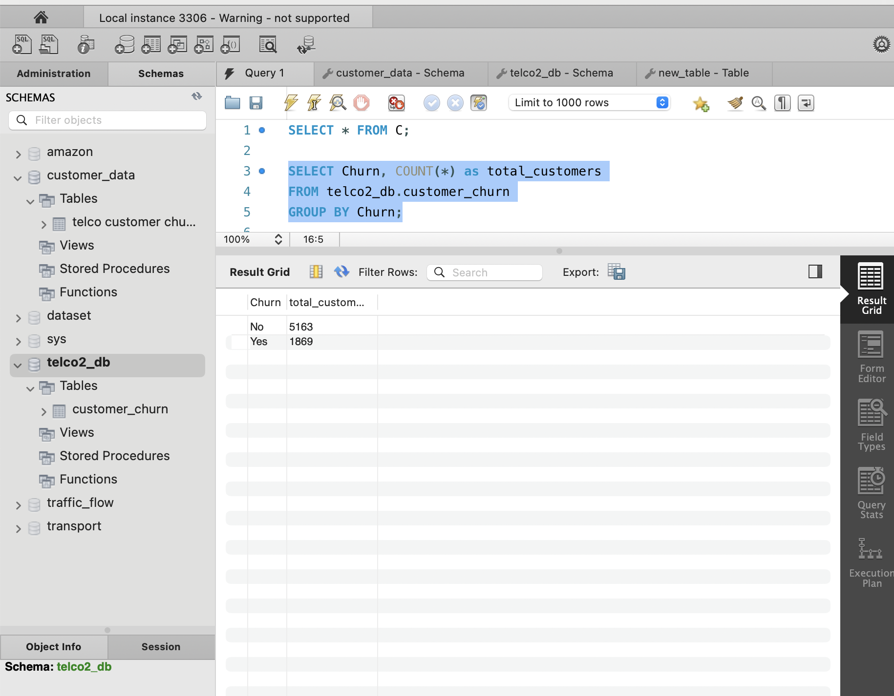

These results show that out of 7,032 customers, 1,869 (approximately 26.6%) had churned, while 5,163 remained active. This suggests that the company is losing over a quarter of its customers

2. **Average Monthly Charges by Churn Status**

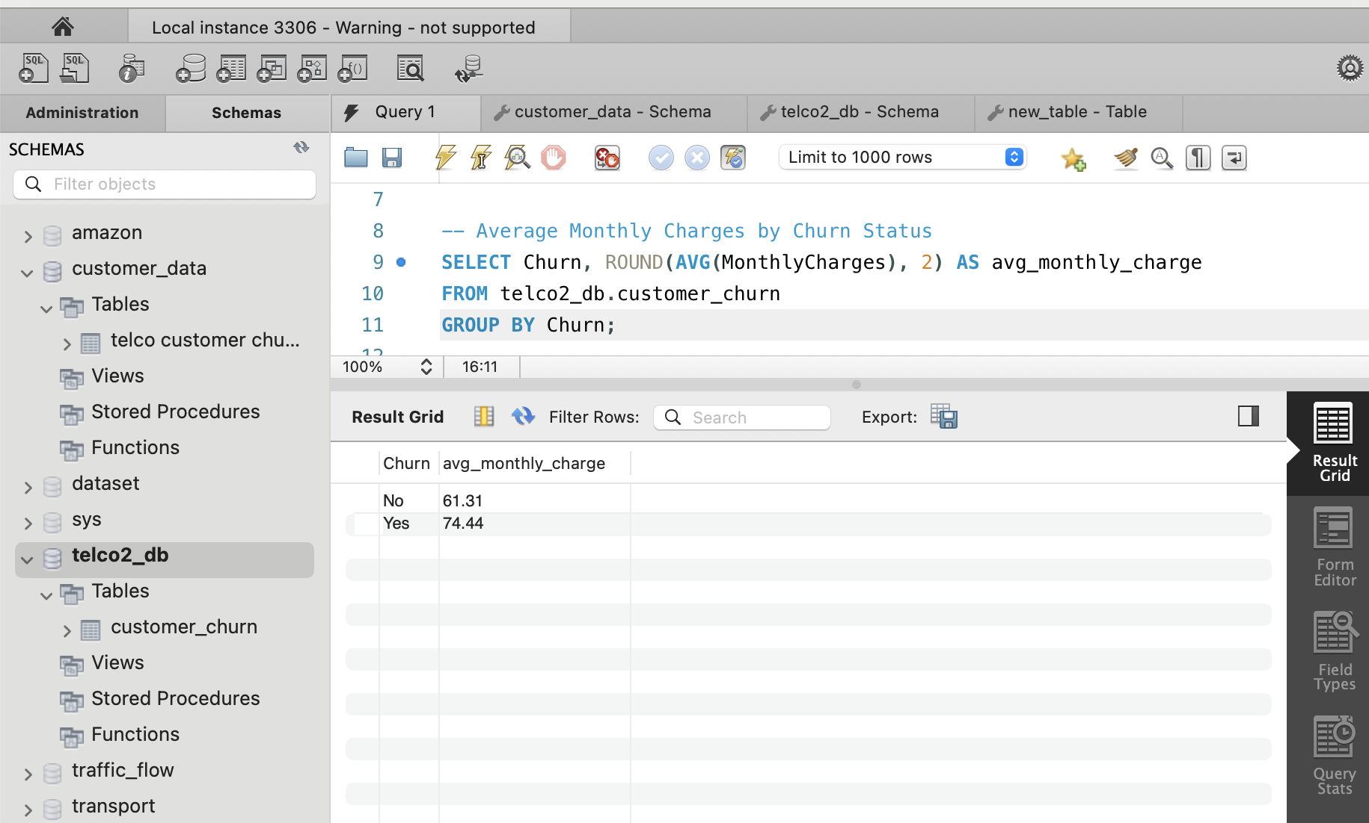

The results showed that customers who churned had a higher average monthly charge (£74.44) compared to those who stayed (£61.31). This suggests that pricing may be a contributing factor to customer churn, and the company should investigate whether high-value customers feel they are receiving sufficient value for the cost.

3. **Customer Count by Contract Type**

The command below was used to analyze the impact of contract type on churn rates.

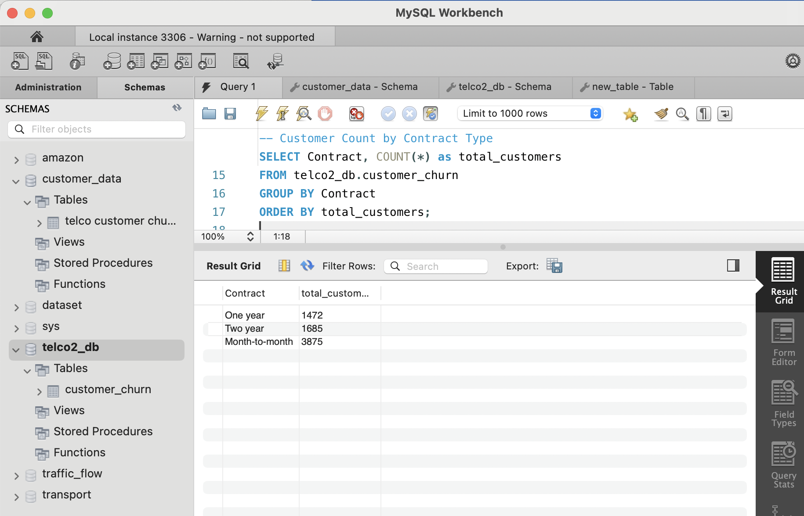

The majority of customers (over 55%) are on month-to-month contracts, which typically come with less commitment. This can be a red flag, as customers with flexible contracts are more likely to leave. Long-term contracts (one or two years) together make up around 45% of the customer base, and these are often associated with lower churn due to contractual obligations.

4. **Top 5 Highest Paying Customers**

We used the following SQL command (see figure below) to identify high-value customers.

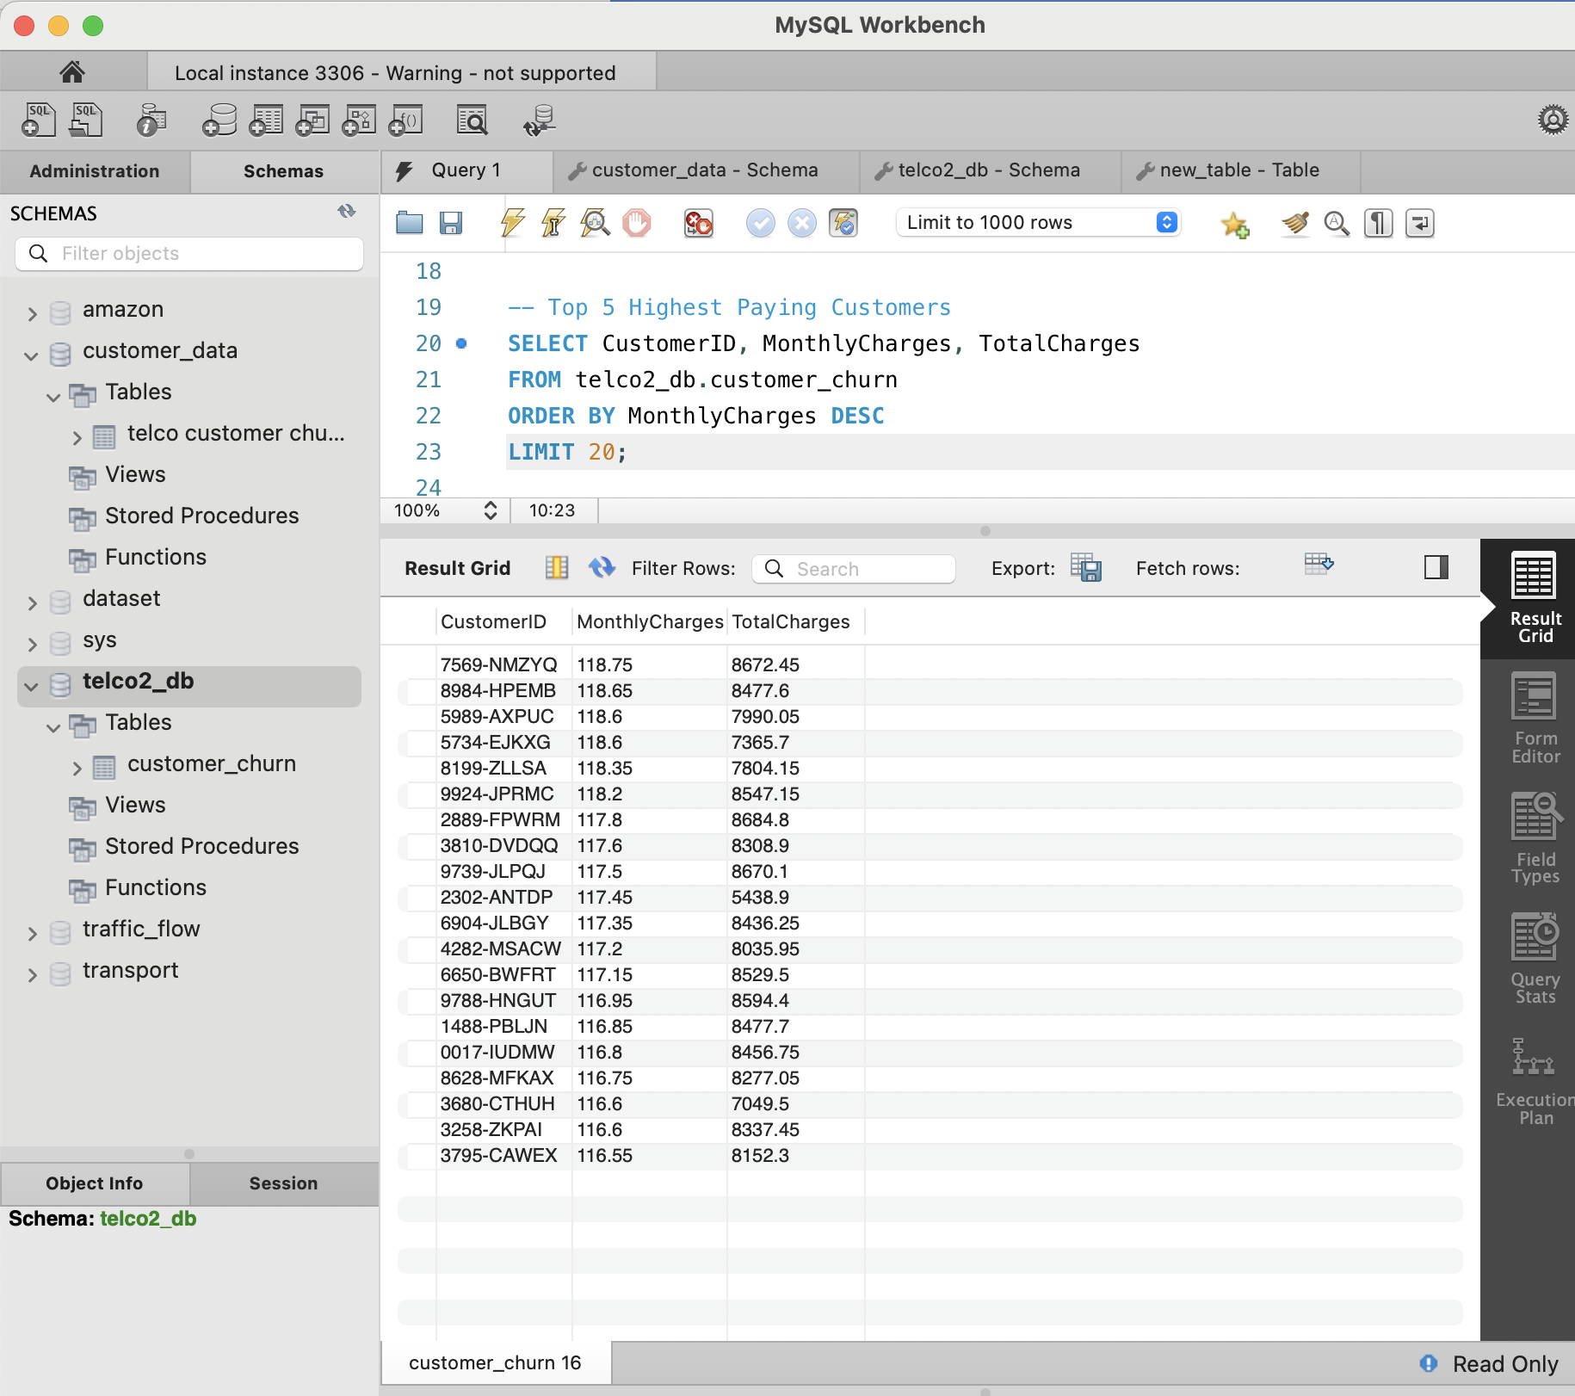

**5. Churn by Internet Service Type**

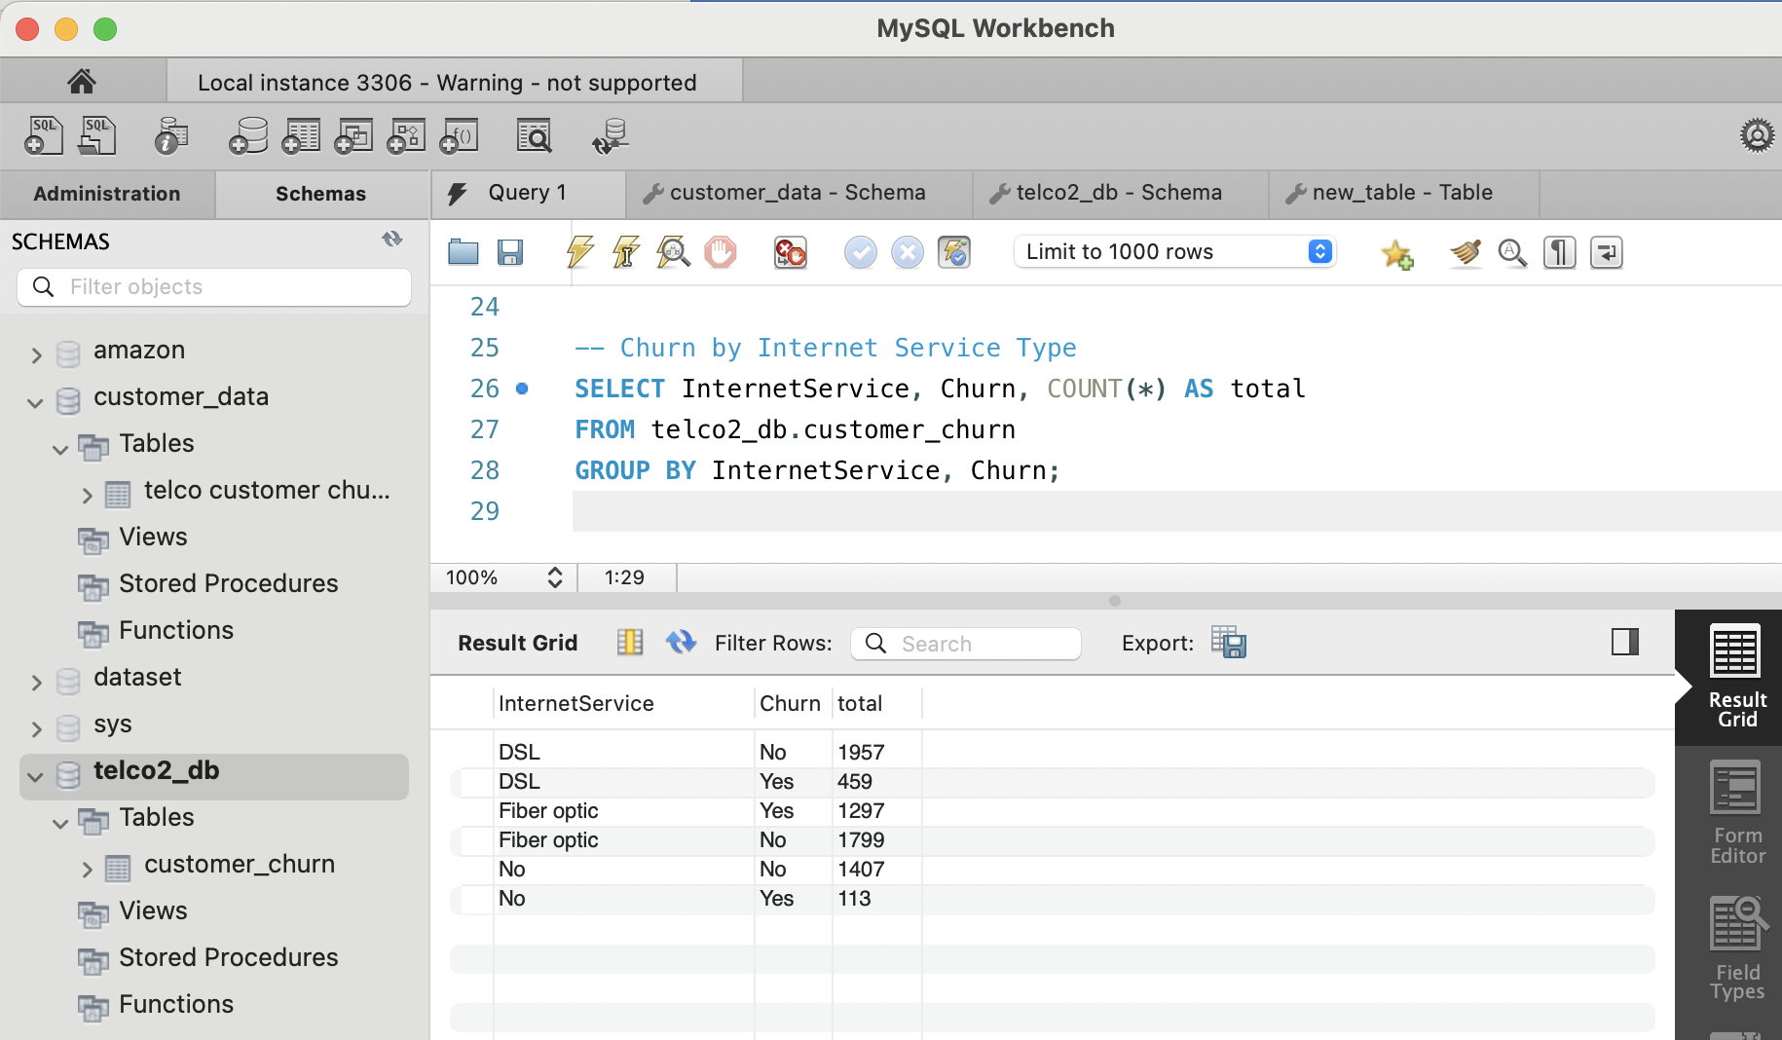

Customers using Fiber optic internet show a higher churn count compared to DSL users. This could suggest dissatisfaction with service reliability or pricing.